RPG Attributes

# Initialise Attributes from a Data table

So far attributes have been initialised by calling init functions. This works, but it’s not the only way. Here’s an alternative

To make things more interesting we’ll add some more attributes to the AttributeSet

Example: Strength. Just copying the vital but changing the specifics. Note the On_Rep for a notif that does not yet exist

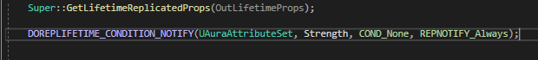

And then we apply for the other attributes

So, the purpose of this exercise is to initialise from a datatable. To do this we need to expose the ability system component to BP, so that we can set a specific asset, the datatable, on that component

To od this we need to open the Aura Player State, where the ASC is located

The ASC properties are now exposed in the player state:

To use a data table to initialise some attributes, we have to add an element to the array Attribute Test called Default Starting Data

You can choose attributes

And a data table to use

But you can’t just use ANY data table – it needs the correct row structure.

Row name is specified by the Attribute Set, a dot, and the attribute name



Base value:

And now back in the player state:

And now in-game:

The struct:

From the parent AttributeSet.h:

Currently it’s mostly useful for setting the initial value of attributes; it implements no functionality for a minimum or maximum, it just inits the values

It’s limited in application, but this can be pretty useful for some cases; You just fill in the values and the ASC does the rest

Most people prefer to initialise using a Gameplay Effect on game start though